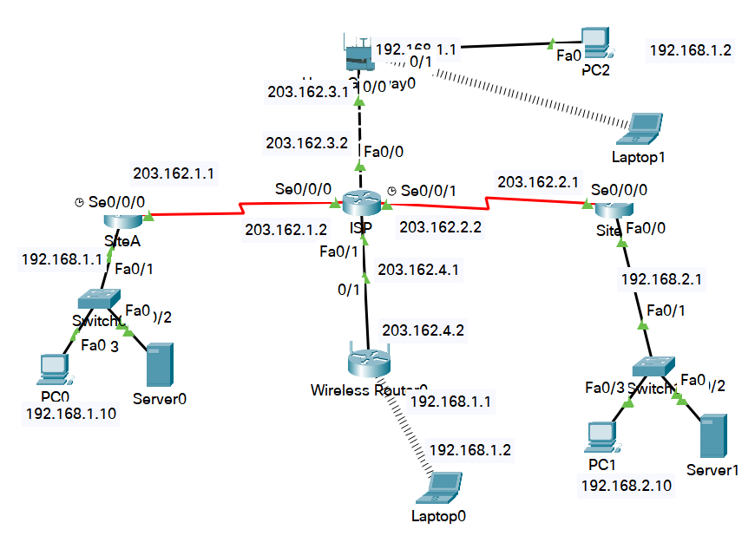

1. Cấu hình NAT out tại 2 site
Tại site-A
RouteAr(config-if)#interface s0/0/0
RouterA(config-if)#ip nat outside
RouterA(config-if)#interface f0/0
RouterA(config-if)#ip nat inside

RouterA(config)#ip access-list extended out
RouterA(config-ext-nacl)#deny ip 192.168.1.0 0.0.0.255 192.168.2.0 0.0.0.255
RouterA(config-ext-nacl)#permit ip 192.168.1.0 0.0.0.255 any

RouterA(config-ext-nacl)#exit
RouterA(config)#ip nat inside source list out interface s0/0/0 overload

routerA(config)#ip route 0.0.0.0 0.0.0.0 203.162.1.2

Tại site-B
RouterB(config-if)#interface s0/0/0
RouterB(config-if)#ip nat outside
RouterB(config-if)#interface f0/0
RouterB(config-if)#ip nat inside

RouterB(config)#ip access-list extended out
RouterB(config-ext-nacl)#deny ip 192.168.2.0 0.0.0.255 192.168.1.0 0.0.0.255
RouterB(config-ext-nacl)#permit ip 192.168.2.0 0.0.0.255 any

RouterB(config-ext-nacl)#exit
RouterB(config)#ip nat inside source list out interface s0/0/0 overload

routerB(config)#ip route 0.0.0.0 0.0.0.0 203.162.2.2
Các pc bên trong có thể ra internet
2. Cấu hình vpn client to site
Tại site-A
Enable NEW access control commands and functions
routerA(config)#aaa new-model
Authentication configurations parameters
routerA(config)#aaa authentication login default local none ; NO authentication

routerA(config)#ip local pool VPNPOOL 192.168.1.20 192.168.1.50

routerA(config)#crypto isakmp policy 10
routerA(config-isakmp)#authentication pre-share
routerA(config-isakmp)#encryption aes 256 ; 256 bit keys
routerA(config-isakmp)#group 2 ; Set the Diffie-Hellman group 2
routerA(config-isakmp)#exit

routerA(config)#crypto isakmp client configuration group NHATNGHE
routerA(config-isakmp-group)#key 123 ; pre-shared key/IKE password
routerA(config-isakmp-group)#pool VPNPOOL ; Set name of address pool
routerA(config-isakmp-group)#netmask 255.255.255.0 ; netmask used by the client for local
routerA(config-isakmp-group)#exit ; connectivity

routerA(config)#crypto ipsec transform-set MYSET esp-3des esp-sha-hmac

routerA(config)#crypto dynamic-map MYMAP 10 ; Specify a dynamic crypto map template
routerA(config-crypto-map)#set transform-set MYSET
routerA(config-crypto-map)#reverse-route ; Reverse Route Injection
routerA(config-crypto-map)# exit

routerA(config)#aaa authentication login VPNAUTH local ; Use local username authentication
routerA(config)#username u1 password 123
routerA(config)#username u2 password 123

routerA(config)#aaa authorization network VPNAUTH local ; Authorization configurations parameters.

routerA(config)#crypto map VPNMAP client authentication list VPNAUTH
routerA(config)#crypto map VPNMAP client configuration address respond
routerA(config)#crypto map VPNMAP isakmp authorization list VPNAUTH
routerA(config)#crypto map VPNMAP 10 ipsec-isakmp dynamic MYMAP

routerA(config)#interface s0/0/0
routerA(config-if)#crypto map VPNMAP

Tại máy PC2, PC1 ( site B) quay vpn về site A:

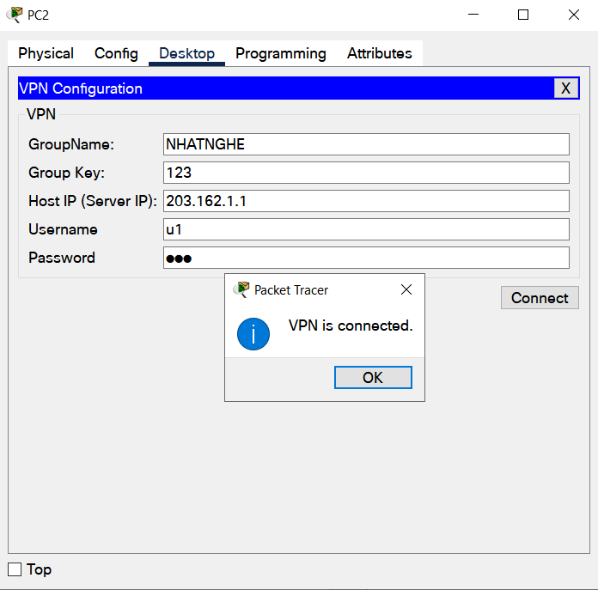

Tại site A: Xem thông tin kết nối VPN:
Router# show crypto ipsec sa ; IPSEC SA table
Router# show crypto ipsec transform-set ; Crypto transform sets
Router#show crypto map ; Crypto maps
Router#show crypto isakmp policy ; Show ISAKMP protection suite policy
Router#show crypto isakmp sa ; Show ISAKMP Security Associations

